Project Design Phase-II
Technology Stack (Architecture & Stack)

Date | 23/09/2026
Team ID | SWTID-2026-5963
Project Name | AI BlogNest
Maximum Marks | 4 Marks

Technical Architecture:

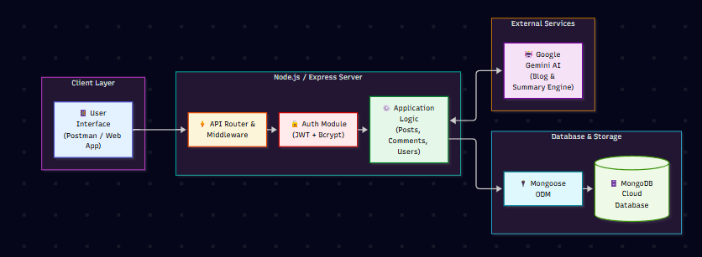

Table-1 : Components & Technologies:
S.No | Component | Description | Technology
 | User Interface | REST API endpoints tested via Postman API client / Web dashboard for user interactions. | Postman / HTML5, CSS3, JavaScript (React.js)
 | Application Logic-1 | Core API routing, server setup, and HTTP middleware processing | Node.js / Express.js Framework
 | Application Logic-2 | User authentication, password encryption, and token verification | JSON Web Tokens (JWT) & bcrypt.js
 | Application Logic-3 | Content lifecycle management, blog drafting, and comment moderation logic | Node.js Express Controllers
 | Database | Object Data Modeling (ODM) layer for schema definitions and data validation | Mongoose ODM
 | Cloud Database | Primary NoSQL document storage for users, blog posts, and comments | MongoDB / MongoDB Atlas .
 | File Storage | Storing image uploads, featured media paths, and static assets | Local Express Static Server / Multer Storage
 | External API-1 | Automated AI blog post creation service from user prompt topics | Google Gemini API (/api/ai/generate-blog)
 | External API-2 | Automated text summarization engine for articles and blog posts | Google Gemini API (/api/ai/summarize)
 | Machine Learning Model | Large Language Model used for natural language processing, post generation, and summaries. | Gemini 3.6 Flash Model
 | Infrastructure (Server / Cloud) | Backend application runtime deployment and local server configuration | Local Node.js Environment / Cloud Hosting (Render / Vercel)

Table-2: Application Characteristics:
S.No | Characteristics | Description | Technology
 | Open-Source Frameworks | Lightweight web application server framework and object mapping library. | Express.js, Mongoose ODM, Node.js
 | Security Implementations | Salted password hashing, stateless token-based authorization, and Role-Based Access Control . | bcrypt.js, JWT Authentication, Custom RBAC Middleware
 | Scalable Architecture | Modular MVC design pattern with clear separation of routes, controllers, and models for easy scaling. | Express Router, Layered Architecture
 | Availability | Non-blocking asynchronous I/O event loop to handle concurrent API requests efficiently. | Node.js Event Loop, PM2 Process Manager
 | Performance | Optimized indexing on MongoDB collections and asynchronous handling of external AI service calls | MongoDB Indexing, Express Compression & Rate Limiting

